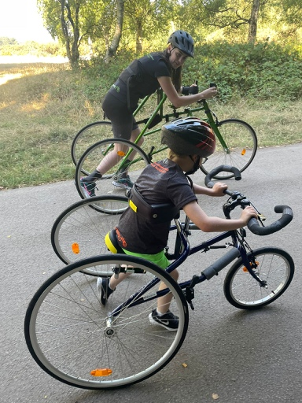
Now I Can Run UK

As an elite athlete with a mild disability I never thought much about how difficult it could be to find accessible sports for those with more severe disabilities. I have a progressive condition and had a massive deterioration in the 2015/16 season meaning I had to withdraw from Rio a week before the team flew out. I thought my career in sport was over but after two years I managed to make it back. I found that my body wasn’t capable of training the distances in the pool needed to be fully fit and competitive so a good friend introduced me to frame running. A Frame Runner is a three wheeled frame where the athlete is supported by a saddle and body plate. The athlete propels against the frame using their feet, and steers using the mobility within their hands and/or arms. For the first time in my life I was able to experience the freedom of running! I could go on dog walks, walk around a park, go where my wheelchair couldn’t due to rocky terrain and attend parkrun! Through social media I was able to meet a family local to my hometown with two sons who had disabilities. The oldest Leo who was 6 at the time and has acquired spastic quadriplegic Cerebral Palsy from having sepsis as an infant that caused a cardiac arrest resulting in a severe brain injury. This means he cannot sit, stand or walk unaided, he only has use of one hand and he cannot speak however he understands everything. His younger brother Bobby was 5 at the time and has a high level spinal cord injury so is paralysed from the shoulder blades down but is really active and has a lot of hobbies, Leo had none! Leo is able to walk if his bodyweight is held burt as he cannot sit unaided the NHS physios would not supply him with a walker as they said he needed to learn to sit first, something he will most likely never be strong enough to do. I thought this was ridiculous and I was able to borrow a frame runner from the Manchester frame running club and drive it down to him for him to try for a couple of months. Straight away he was doing laps around the garden on the frame runner and absolutely loved it! It was the first time he’d been able to move on his own power without the help of his electric wheelchair! I knew at this moment I needed to fundraise to get him his own frame and that’s what I did! The NHS physio was able to see him running around on the frame and Leo now has a walking frame and well as his own frame runner. This was a really special moment for me as I know what the feeling of getting onto a frame runner for the first time feeling like and the freedom it brings! This really made me think about how many other Leo’s are out there! Midway through last season I moved from Manchester to Loughborough and decided I wanted to set up a frame running club not only for Leo who lives in Birmingham but for all of the east midlands based kids and adults with neurological impairments to have the opportunity to experience the freedom of running, I think everyone deserves to experience this! Last year I spent a month travelling around Australia and got to meet Amy Tobin who two years ago set up the non for profit Now I Can Run enabling anyone with a disability in Australia to try frame running. What Amy had achieved in just two years is absolutely incredible. There are over 200 frame runners in Queensland alone! Now I Can Run is now also in Germany and New Zealand. I’m teaming up with Amy to make my club the first UK Now I Can Run, it will be now as Now I Can Run East Midlands. My ten year goal is to make sure no one is furtherer than an hour away from a frame running club in the UK, next year we will expand to Lilleshaw for our West Midlands location that I’m now working on behind the scenes.
So why am I asking for your help? Well as you can probably imagine frame runners aren’t cheap at £2,000-3,0000 per frame depending on size, there are 5 sizes (plus a tiny one for 18 months plus but we don’t use these yet) as well as lots of different accessories to customise the support needed for each individual depending on needs which are £250-500 each! I’m hoping to have the Loughborough club up and running as soon as possible. Our first taster day last month was a huge success with many wanting to come to weekly sessions. So far we’ve received a charity grant for 6 frames and some accessories that and I was able to use fundraising money to buy some second hand and ex demo frames but we only have one of each size frame in both the Petra (heavier frames) and RAD (lightweight frames). We cant start until we have liability insurance but are we don’t have enough for the insurance and everything else we need like cones, ladders ete. We also need to buy hand grip aids for those who cannot grip handlebars and foam padding to prevent bruises from the frames. There are also some used/demo frames plus spares up for sale from the old UK supplier in the sizes we desperately need for £2,000 so hoping to raise enough to buy those too. I’m unable to do any fundraising challenges myself until after the Paralympic Games in Paris but I really want to set the club up as soon as possible so the kids and adults that attended the taster day can have access to weekly session and not have to wait until next year to experience the joy of running again!

Thank you for considering helping Now I Can Run UK!

